ASSIGNMENT 4.2

2303A51574

BATCH-29

Task Description-1
• Zero-shot: Prompt AI with only the instruction. Write a Python function to determine
whether a given number is prime

CODE:
def is_prime(n):
if n < 2:
return False
if n == 2:
return True
if n % 2 == 0:
return False
for i in range(3, int(n**0.5) + 1, 2):
if n % i == 0:
return False
return True

# Get input from user
num = int(input("Enter a number: "))

# Check and display result
if is_prime(num):
print(f"{num} is a prime number")
else:
print(f"{num} is not a prime number")

OUTPUT:
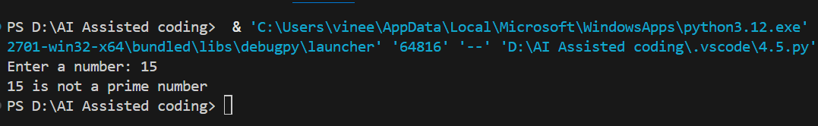
Task Description-2
• One-shot: Provide one example: Input: [1, 2, 3, 4], Output: 10 to help AI generate a
function that calculates the sum of elements in a list.

CODE:
# Calculate the sum of elements in a list
numbers = [1, 2, 3, 4, 5]
total = sum(numbers)
print(f"Sum of the list: {total}")

OUTPUT:

Task Description-3
• Few-shot: Give 2–3 examples to create a function that extracts digits from an
alphanumeric string.
Expected Output-3
• Accurate function that returns only the digits from alphanumeric string.
CODE:
def extract_digits(s):
return ''.join([char for char in s if char.isdigit()])

print(extract_digits("abc123def456")) # Output: 123456
print(extract_digits("hello42world")) # Output: 42

OUTPUT:
Task Description-4
• Compare zero-shot vs few-shot prompting for generating a function that counts the
number of vowels in a string.
Expected Output-4
• Output comparison + student explanation on how examples helped the model.

SOLUTION:
Aspect | Zero-Shot Prompting | Few-Shot Prompting
Examples provided | None | One or more
Prompt length | Short | Longer
Output reliability | Good | Very high
Code style control | Limited | Better
Handles edge cases | Depends on model | More consistent
Best used when | Task is simple | Task needs precision
Risk of misinterpretation | Slightly higher | Lower
Task Description-5
• Use few-shot prompting with 3 sample inputs to generate a function that determines
the minimum of three numbers without using the built-in min() function.
Expected Output-5
• A function that handles all cases with correct logic based on example patterns.
CODE:

def min_of_three(a, b, c):
"""
Determines the minimum of three numbers without using built-in min().

Examples:
>>> min_of_three(5, 2, 8)
2
>>> min_of_three(-1, -5, 3)
-5
>>> min_of_three(10, 10, 10)
10
"""
if a <= b and a <= c:
return a
elif b <= a and b <= c:
return b
else:
return c

# Test cases
print(min_of_three(5, 2, 8)) # Output: 2
print(min_of_three(-1, -5, 3)) # Output: -5
print(min_of_three(10, 10, 10)) # Output: 10

OUTPUT:

